**Day 6**

**Java Access, Modifiers. Recursion Inheritance**

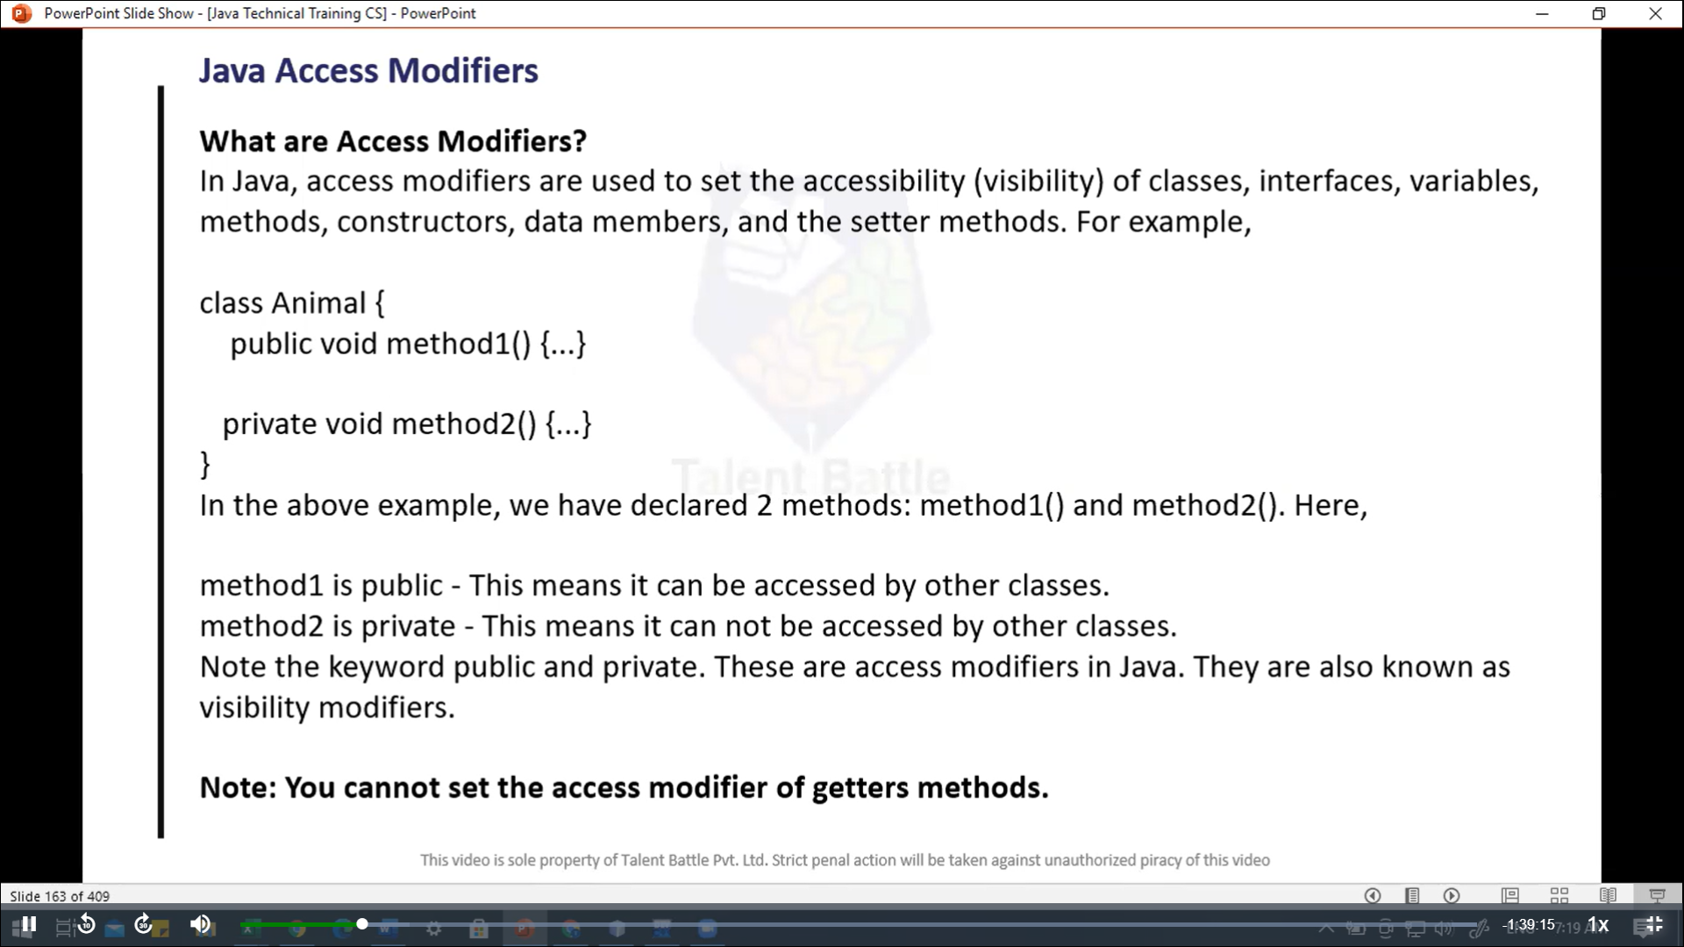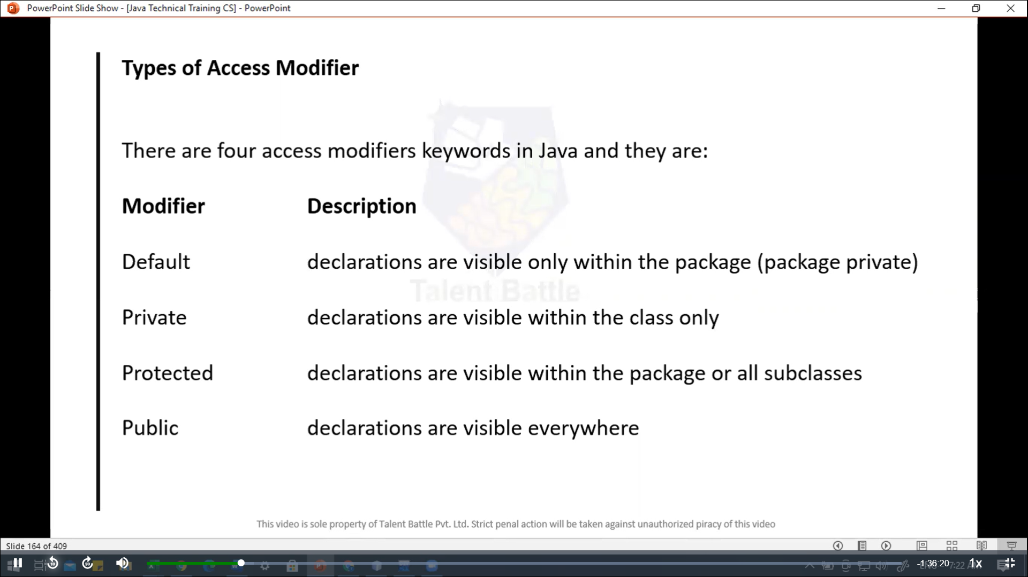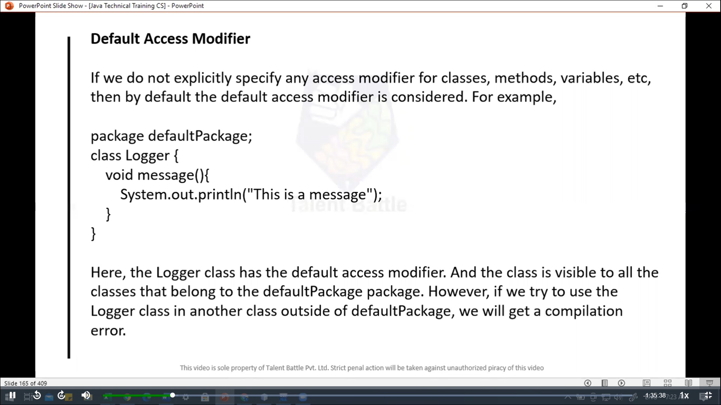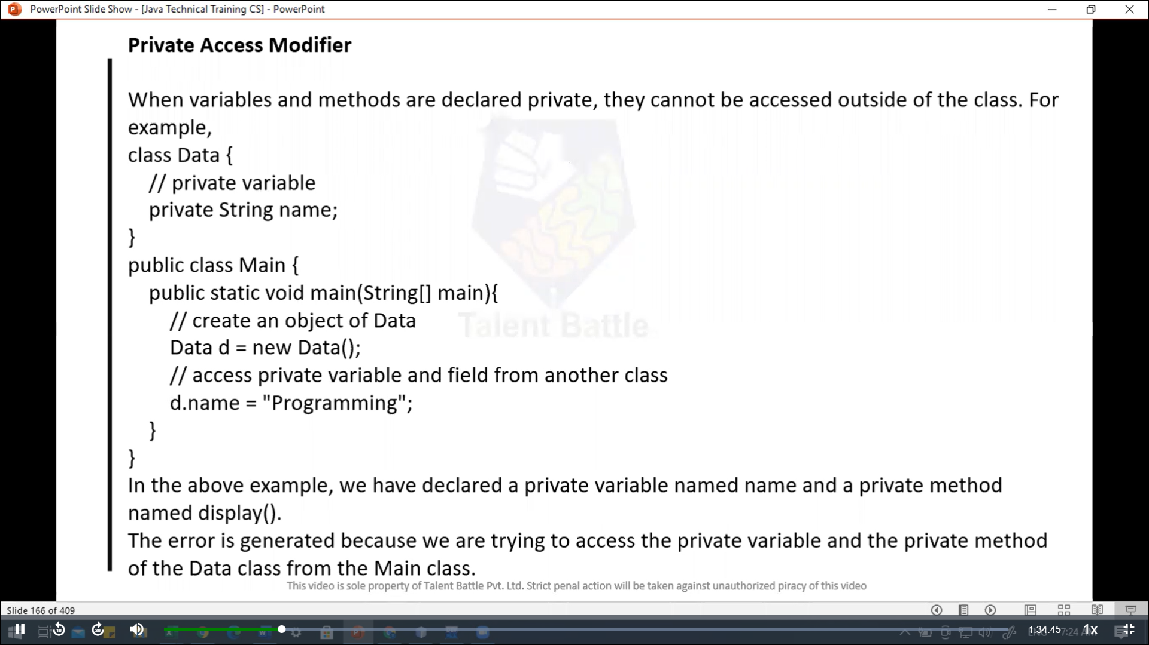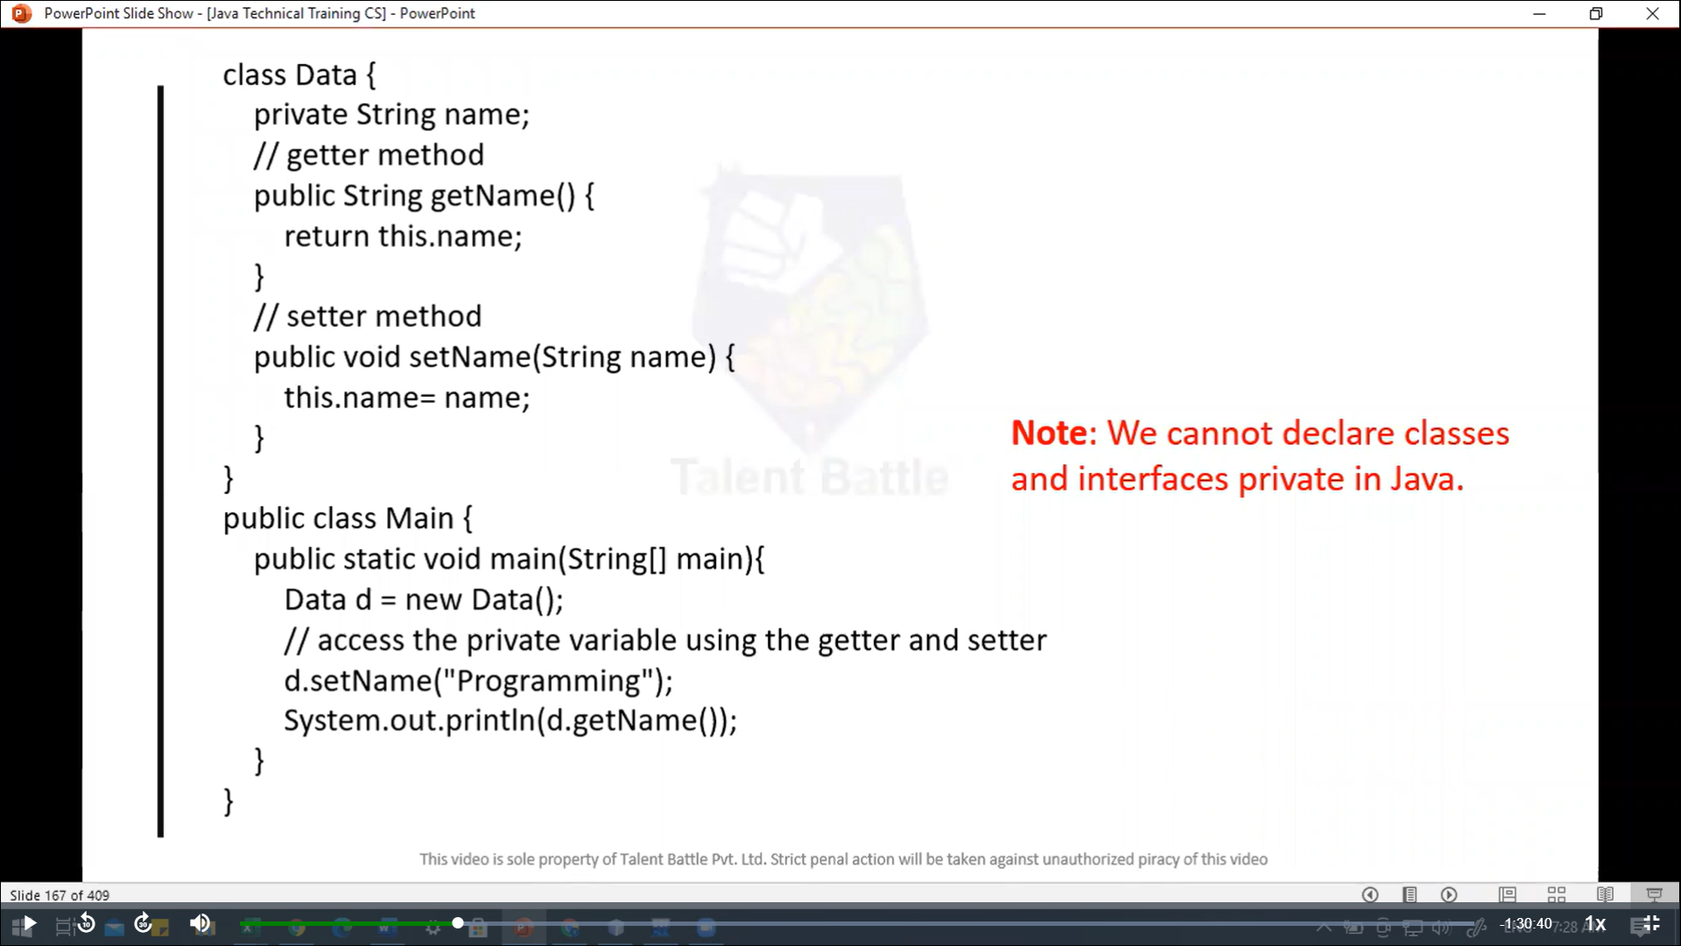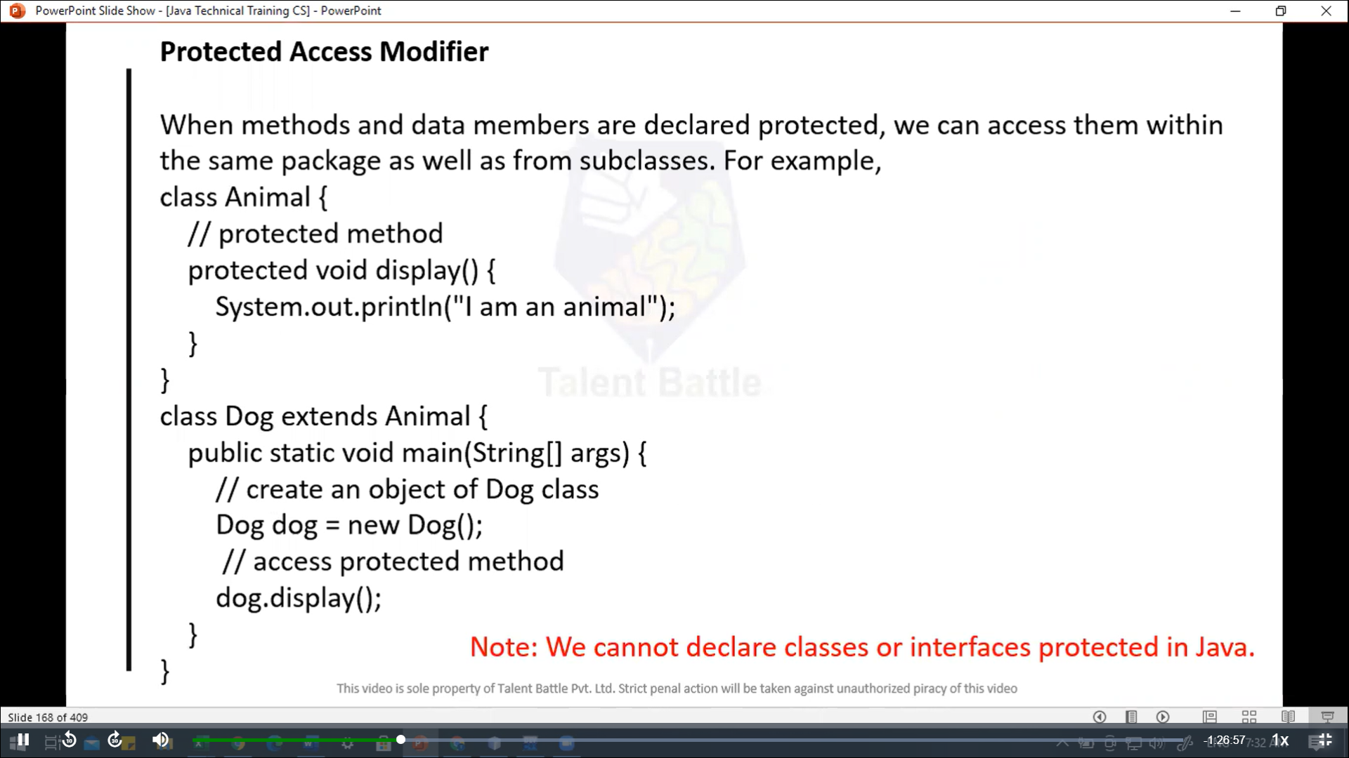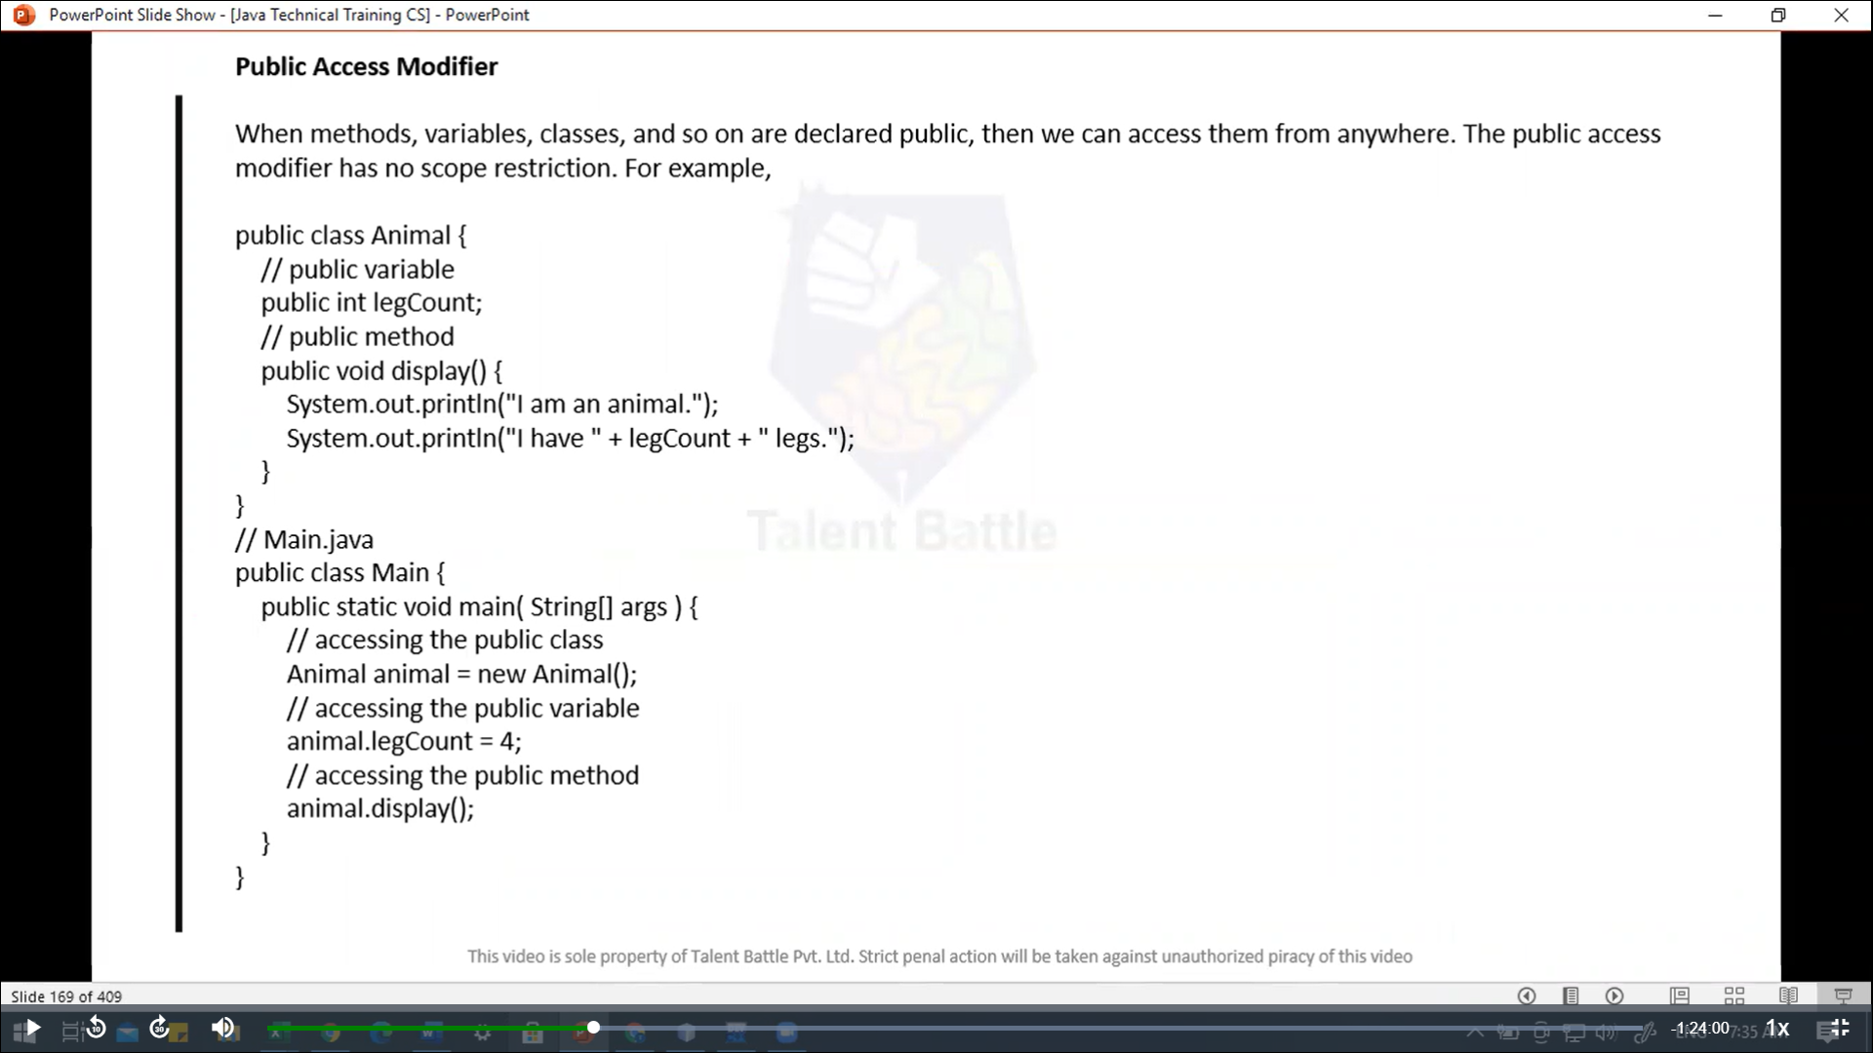

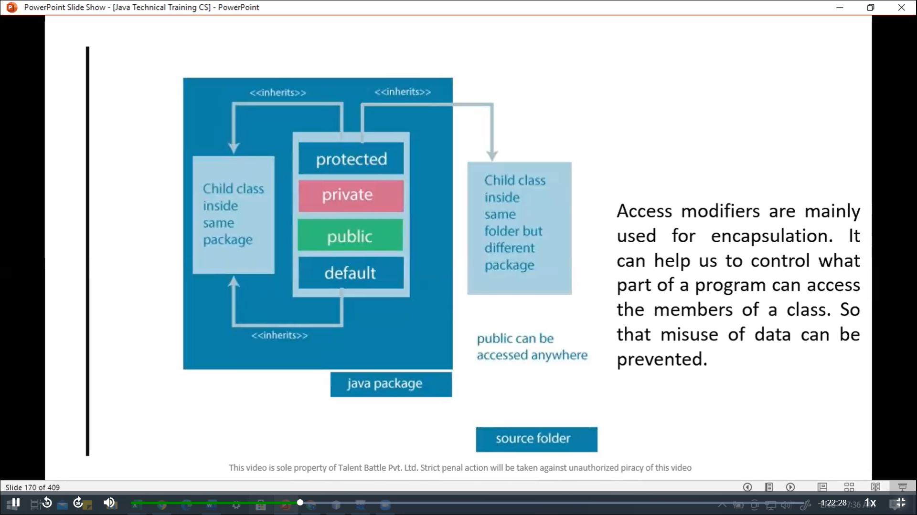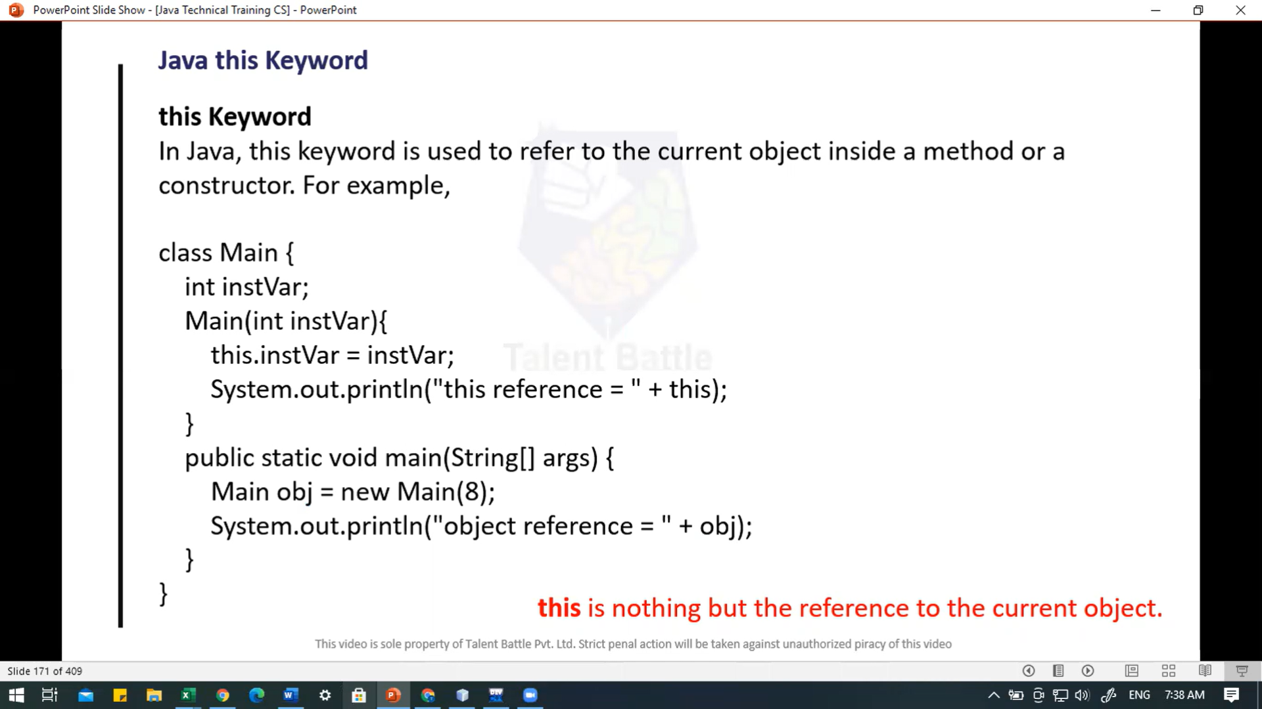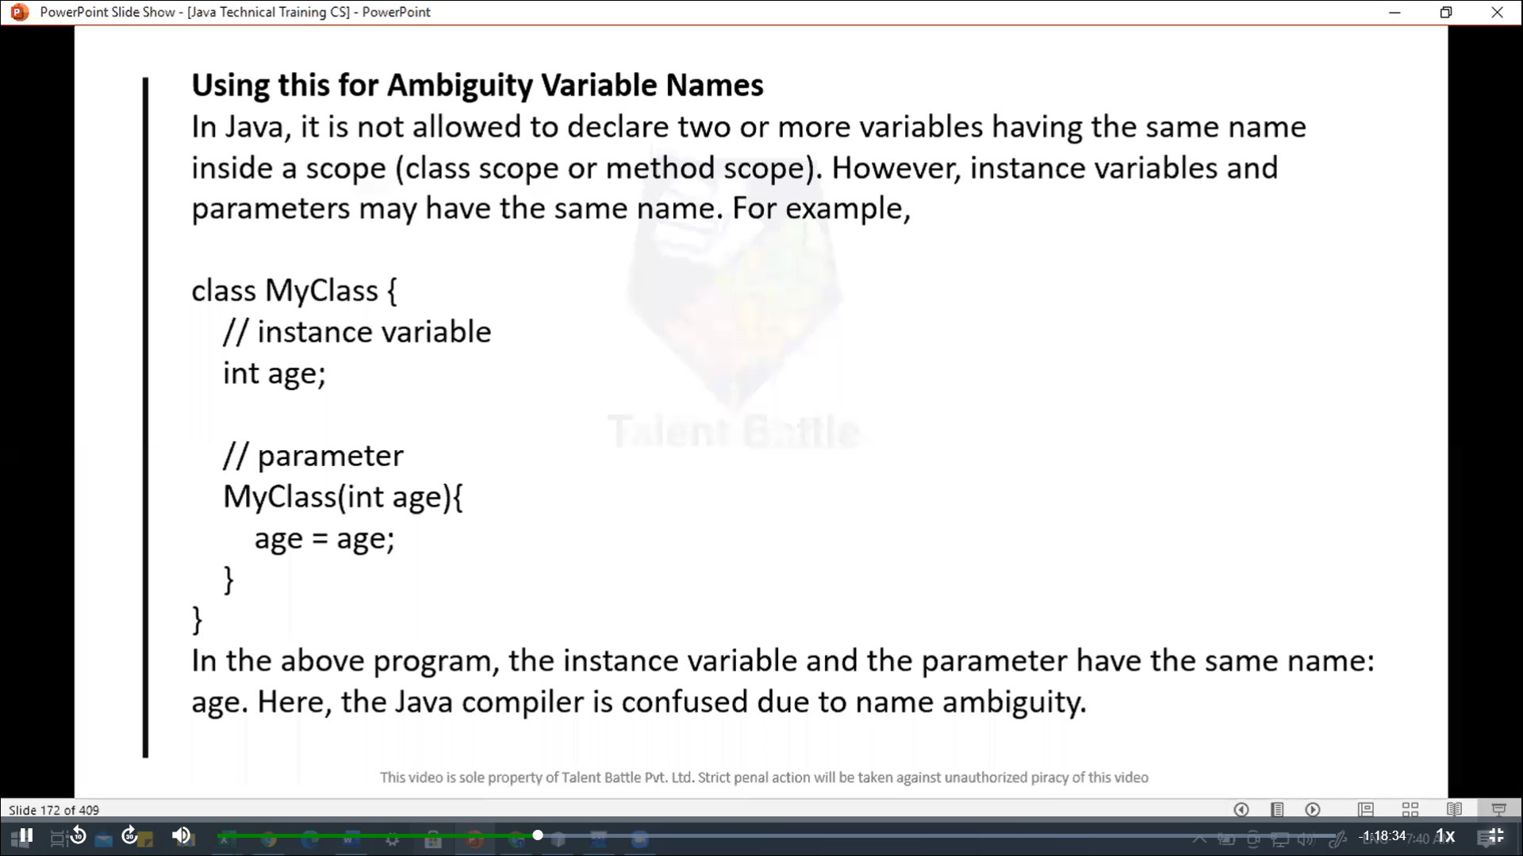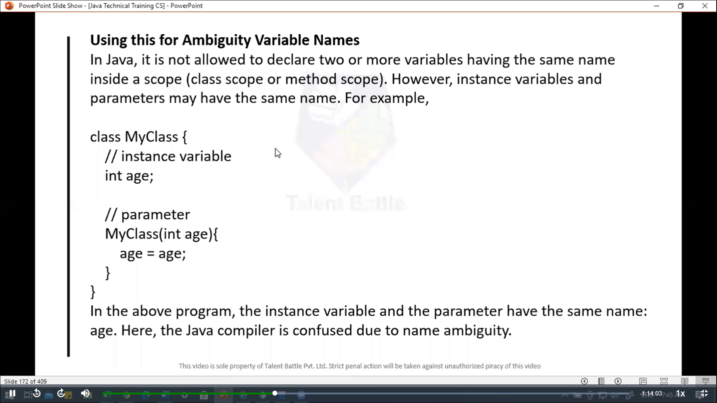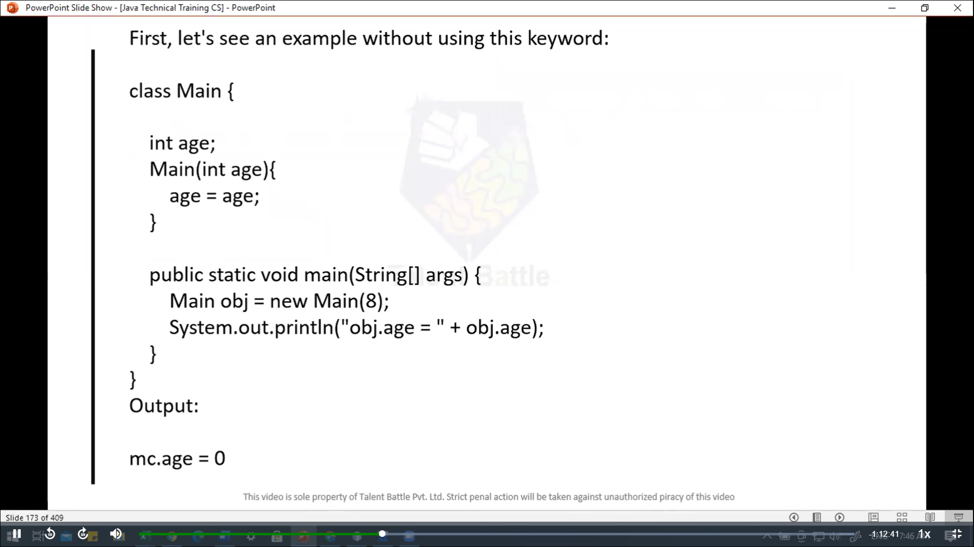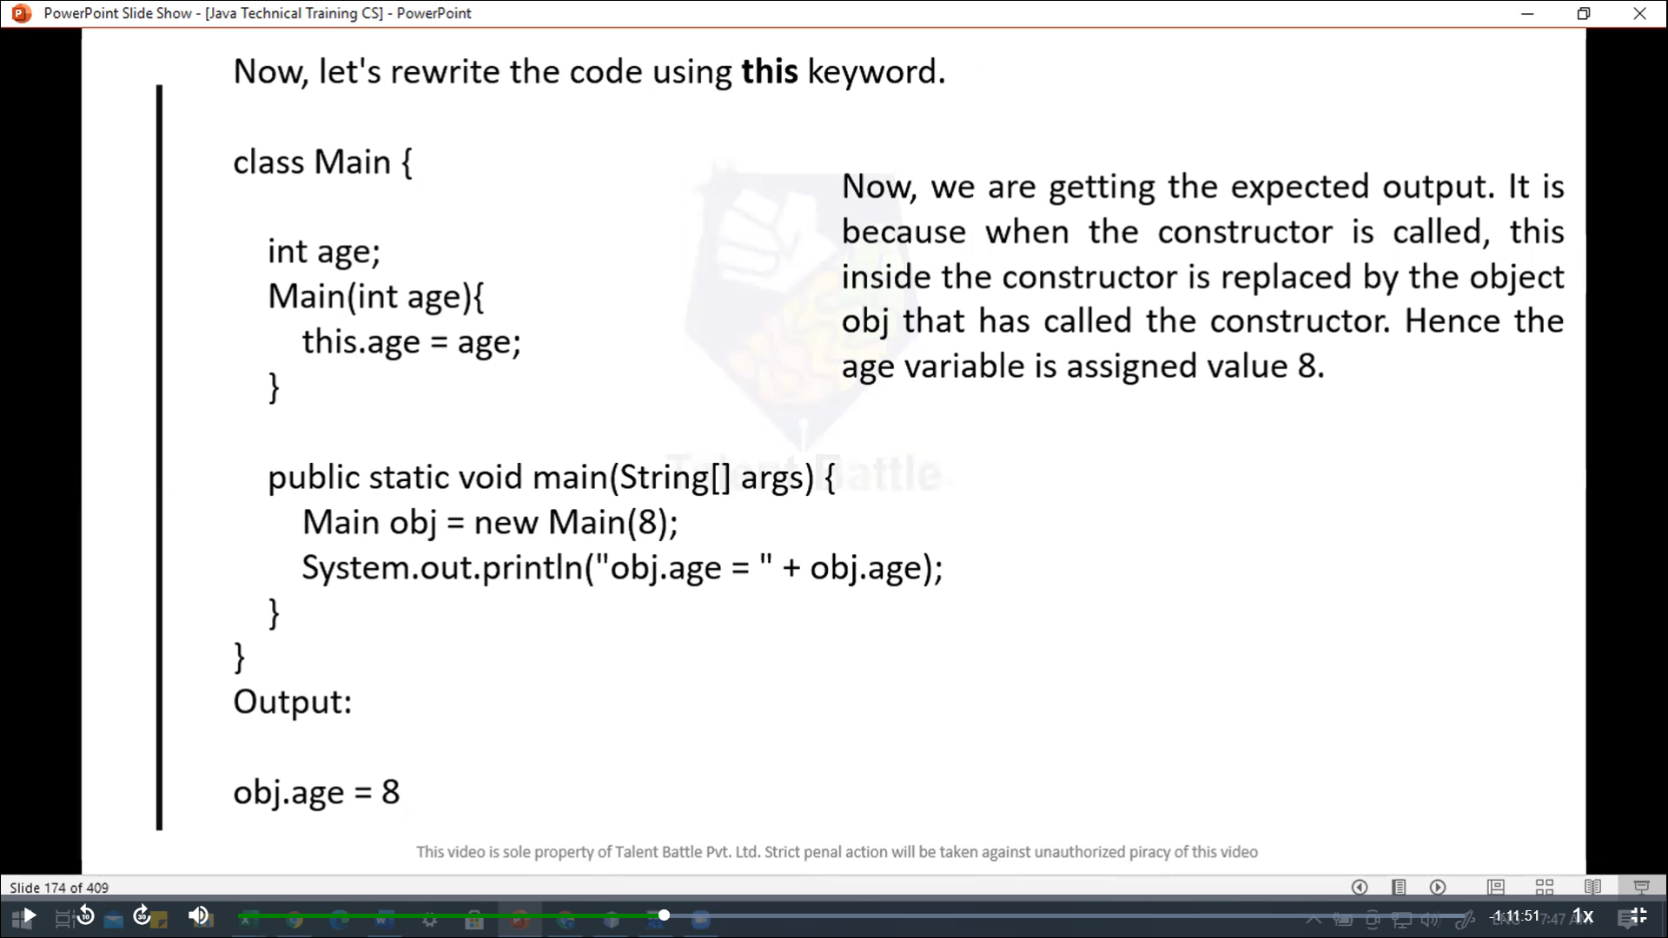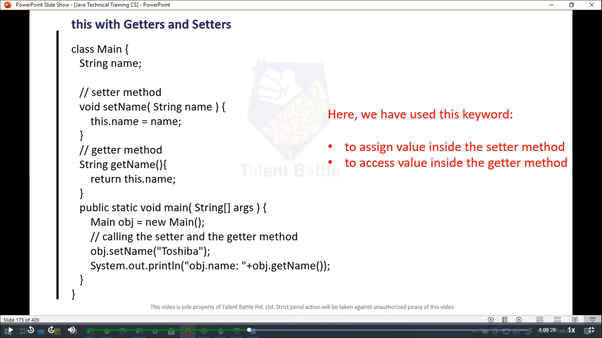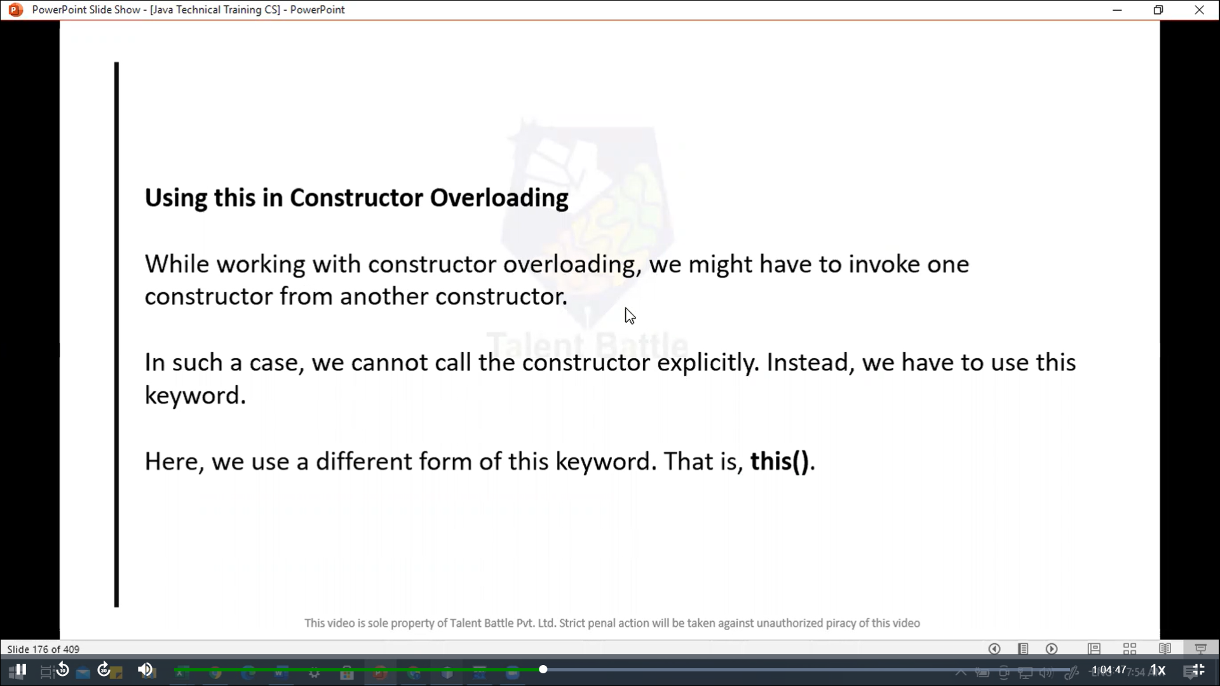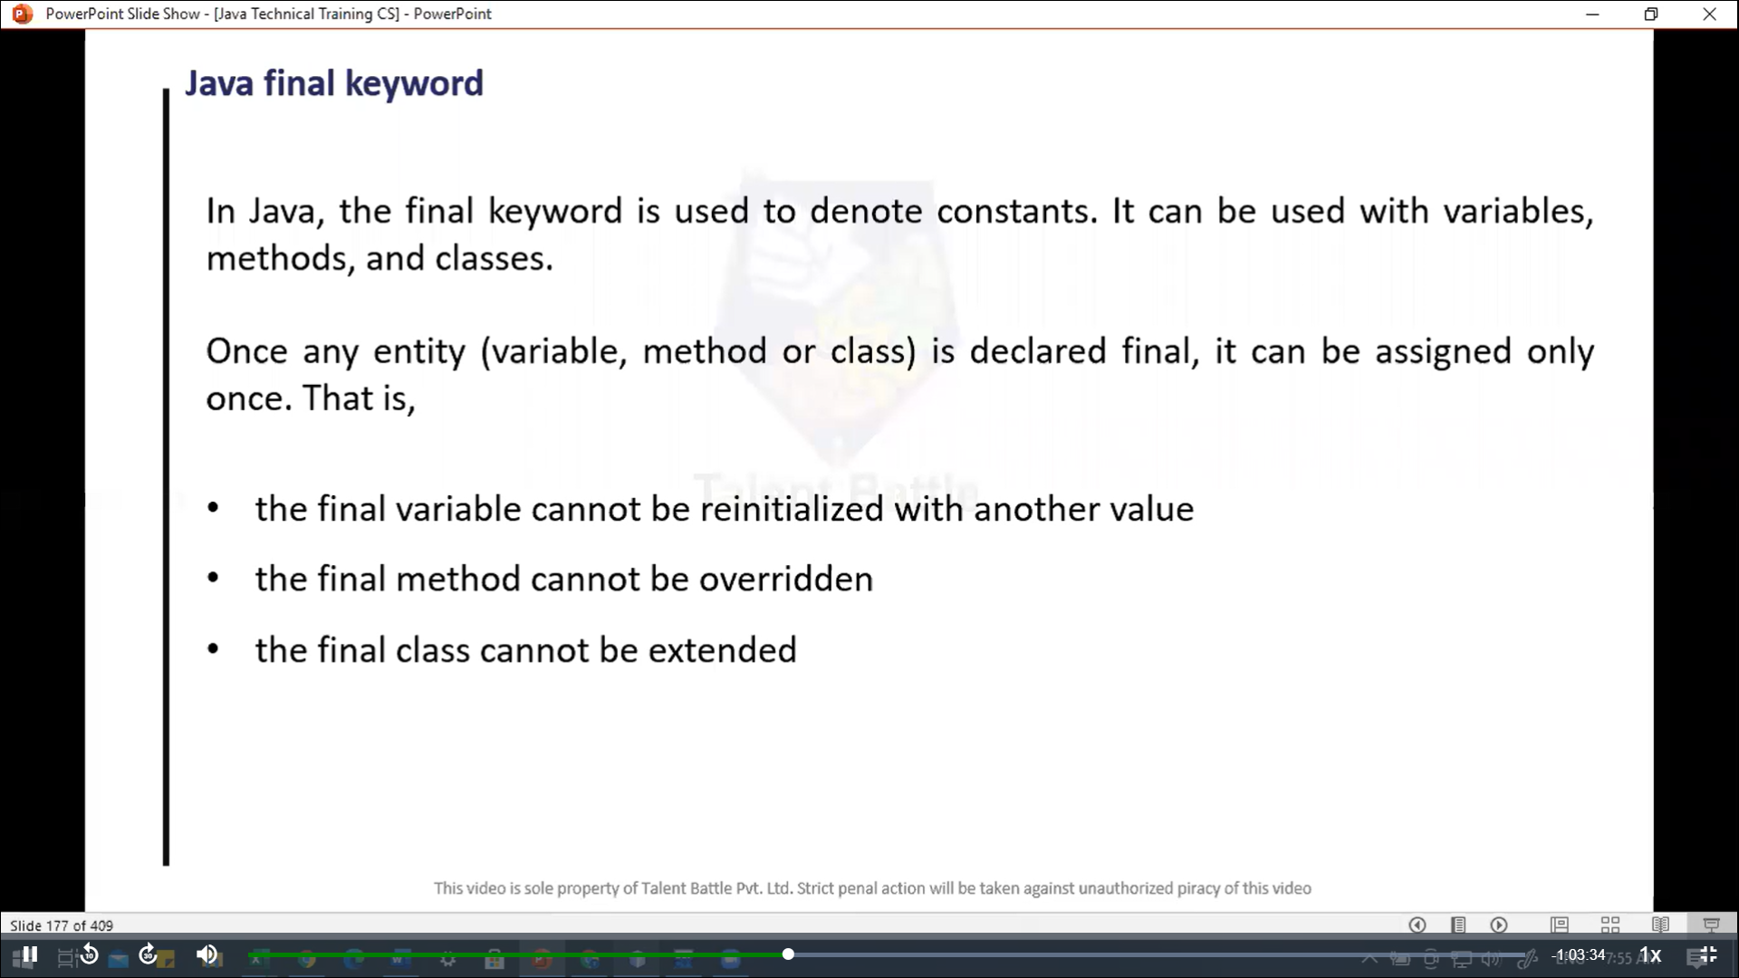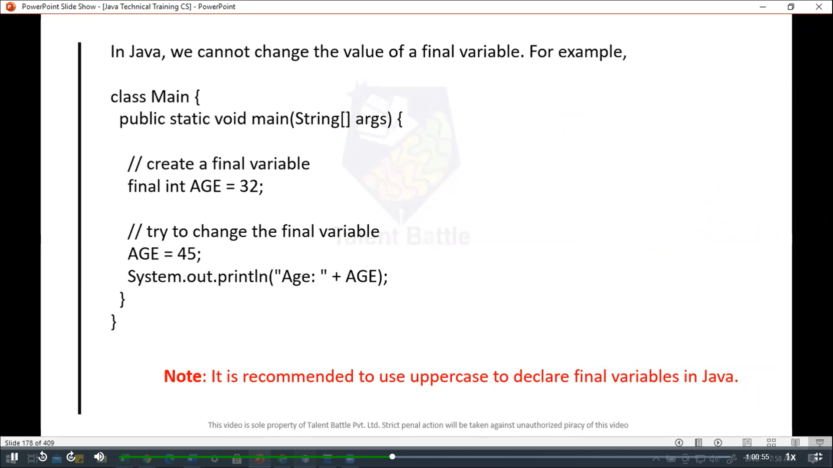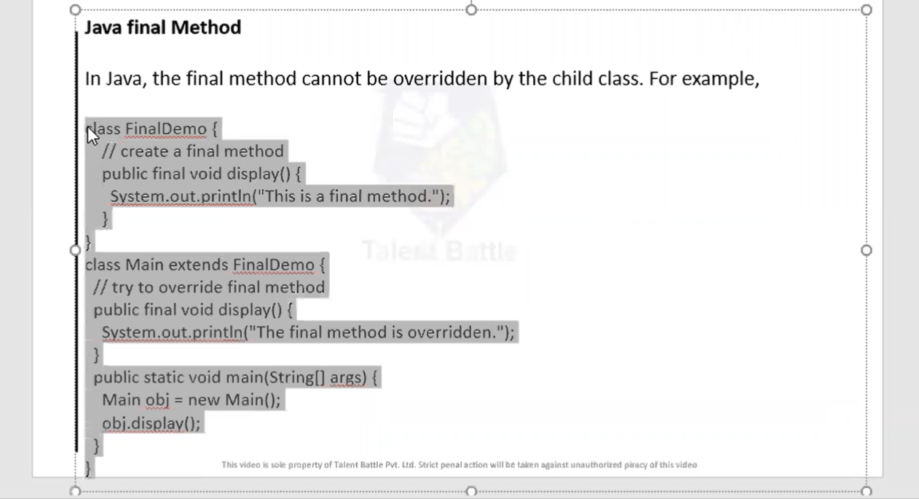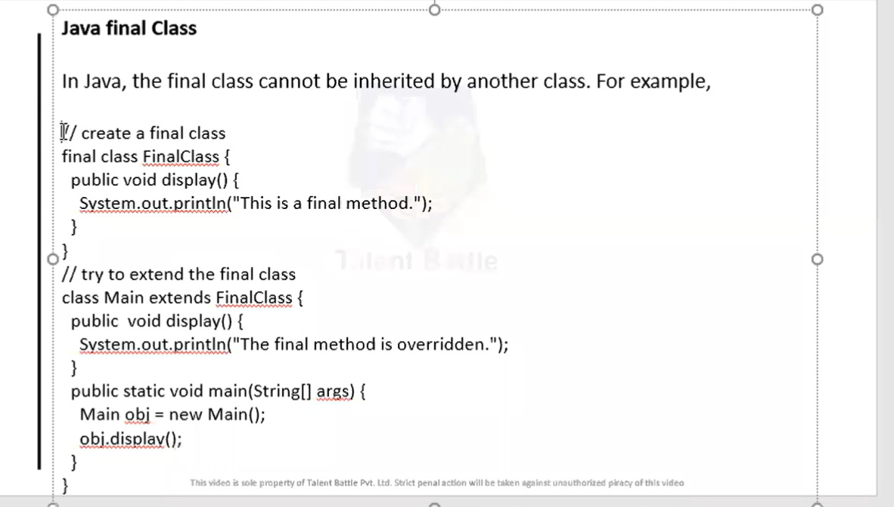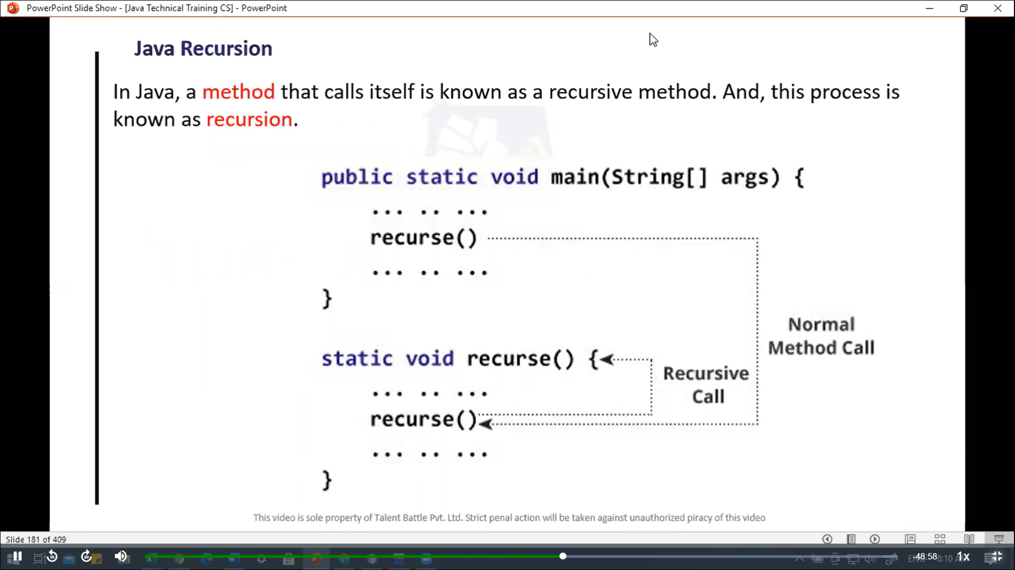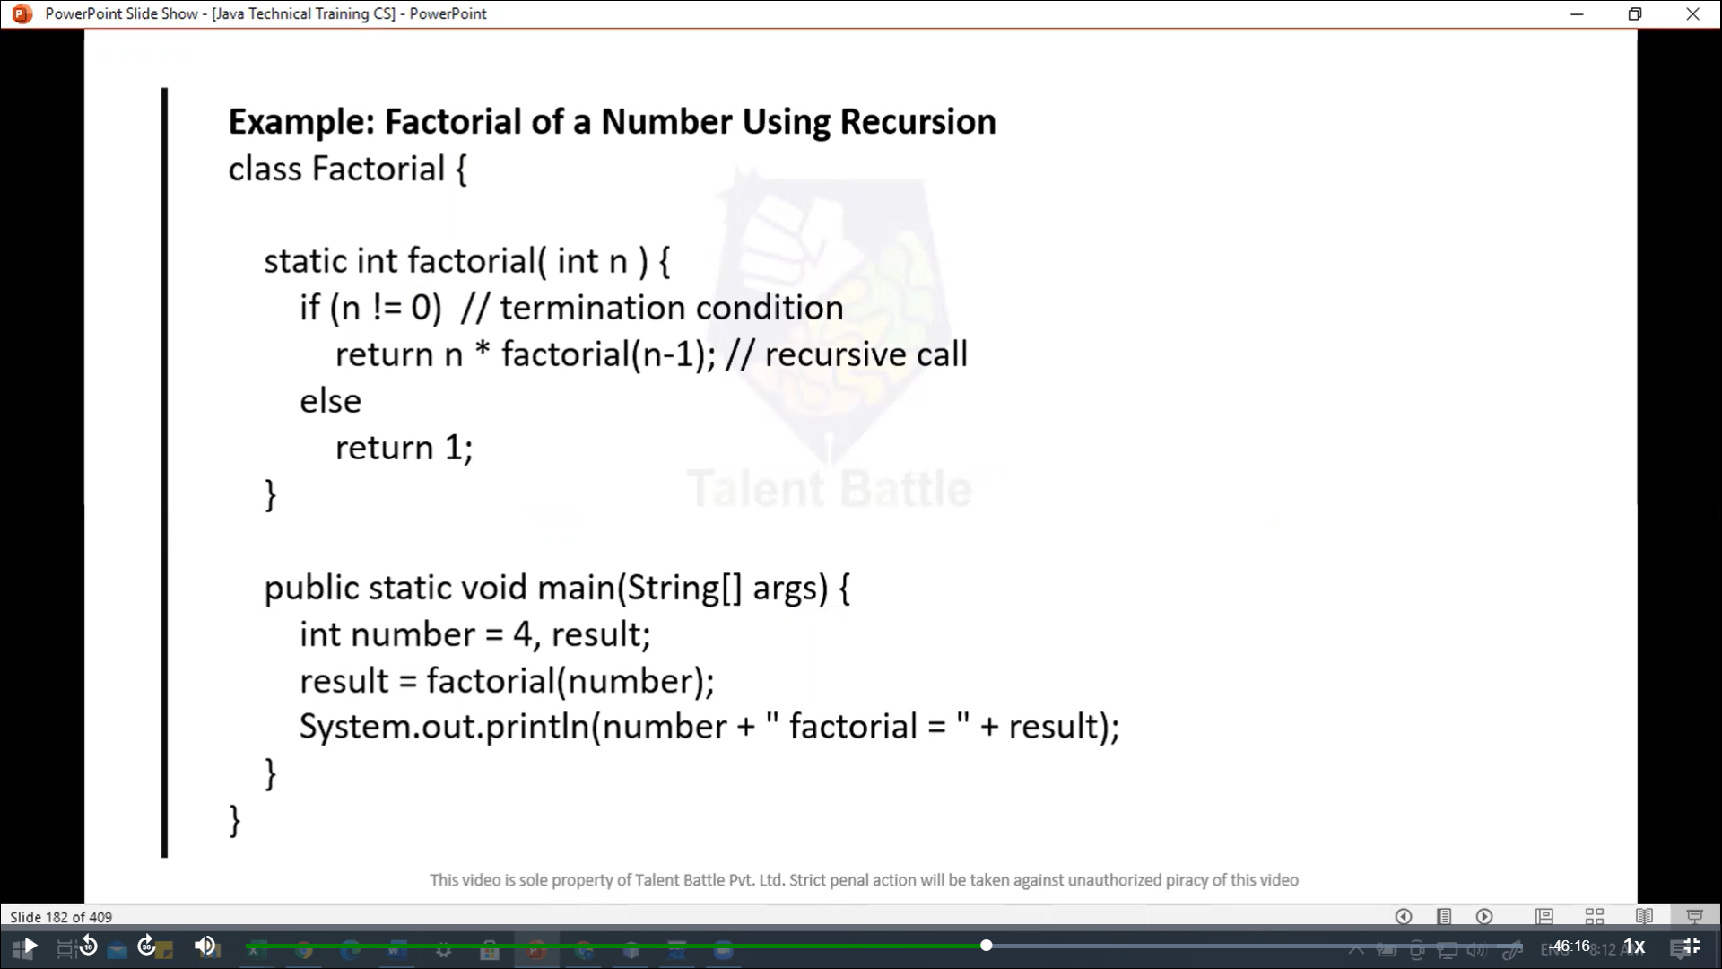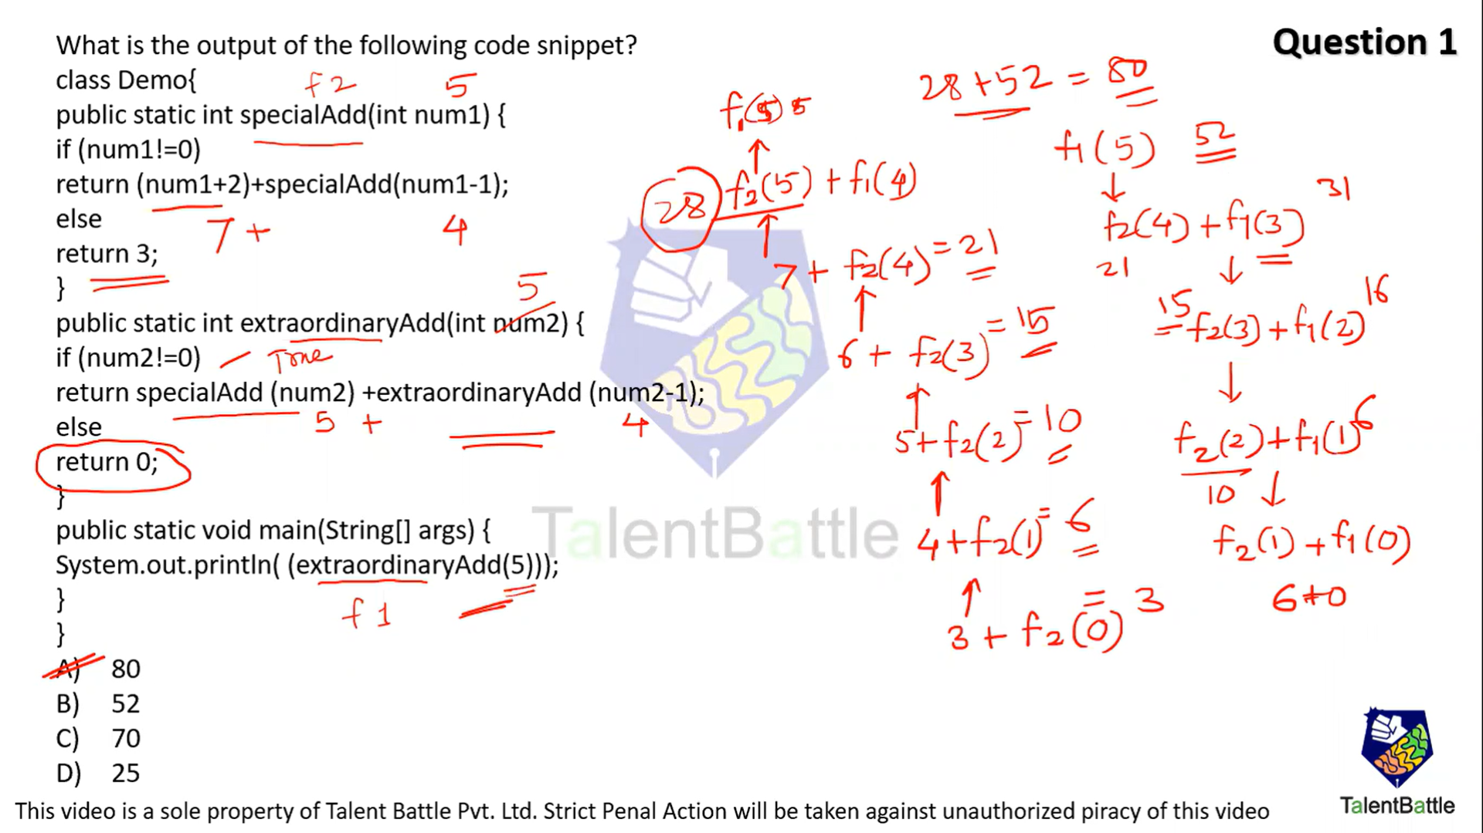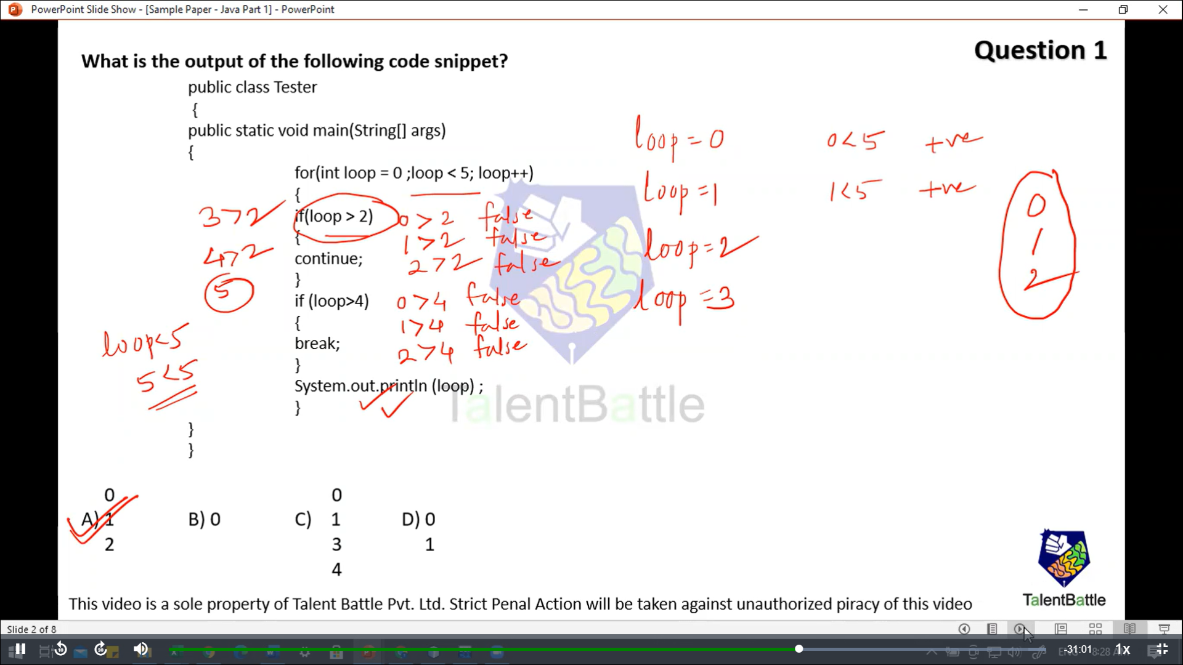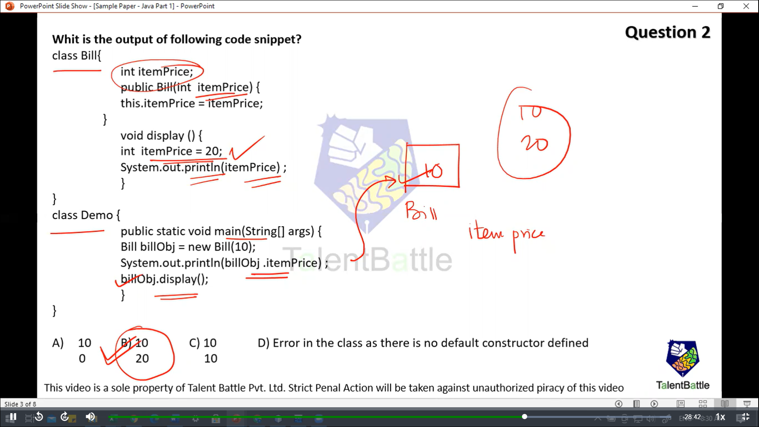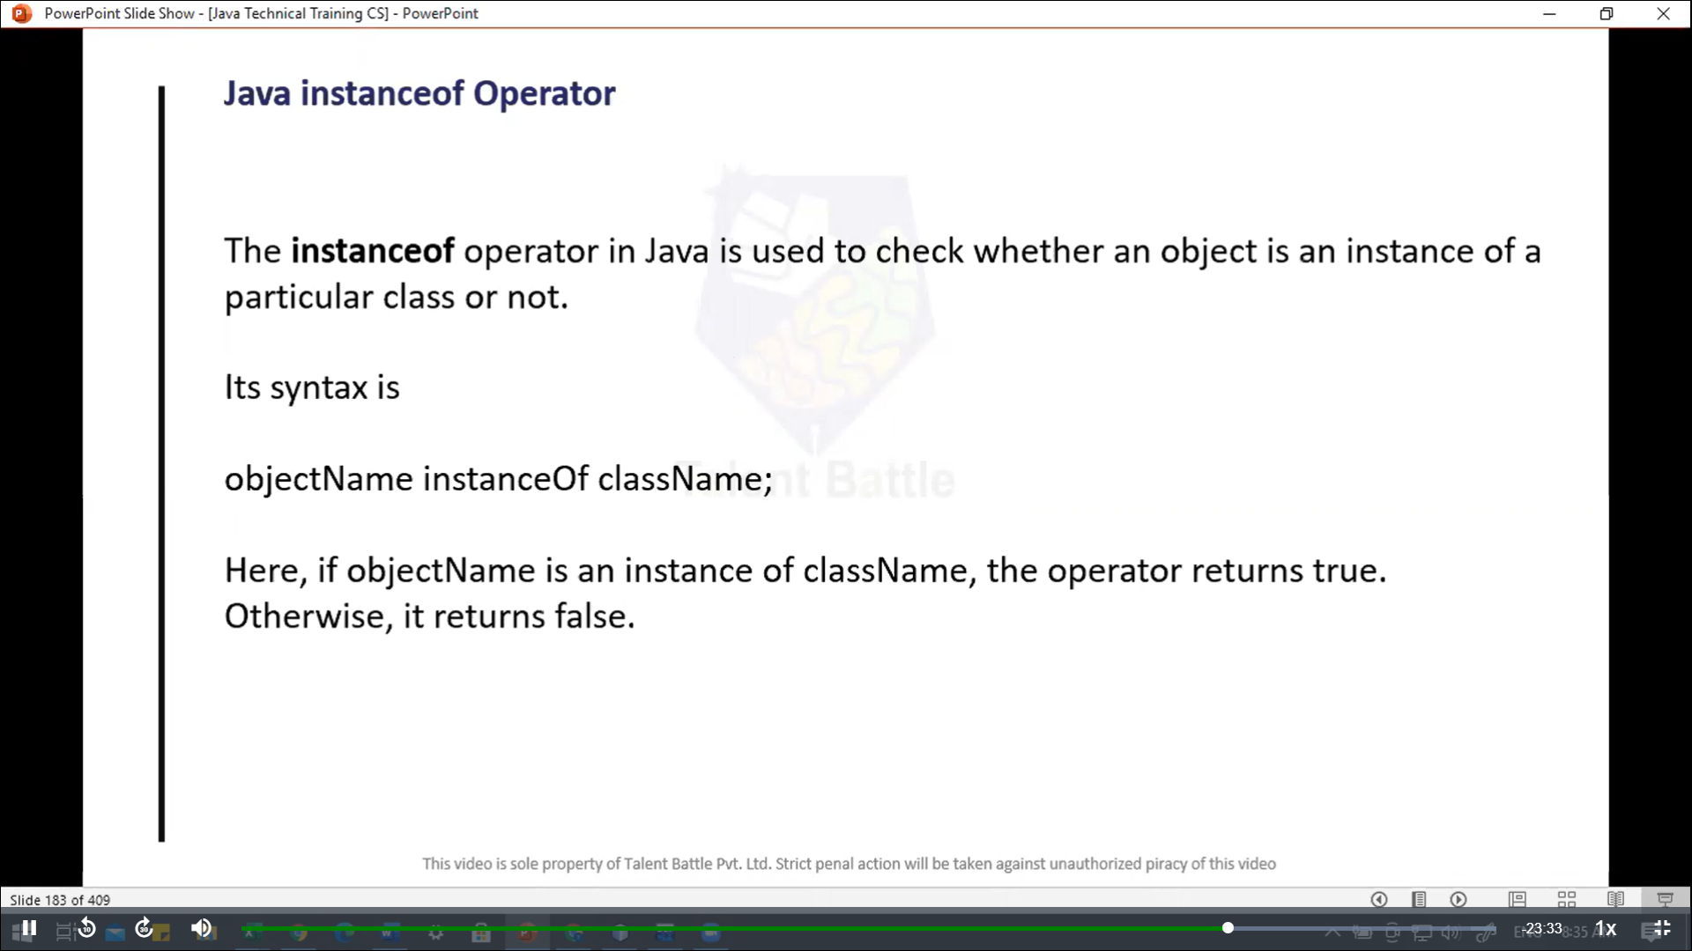

**Java Inheritence**

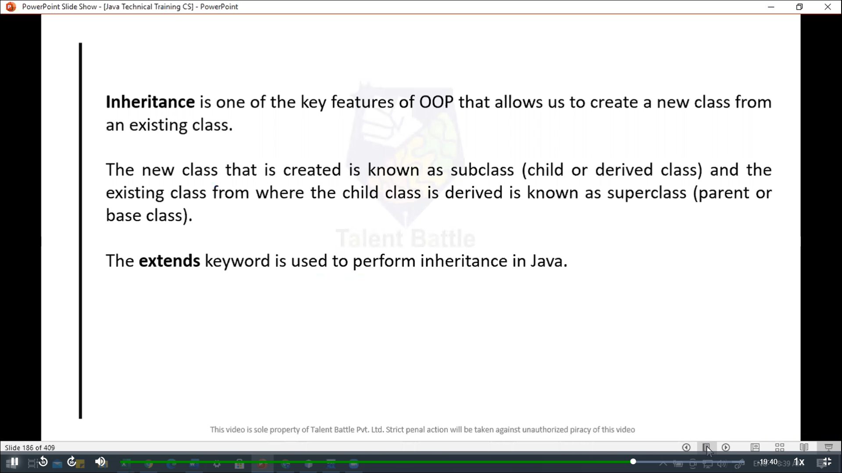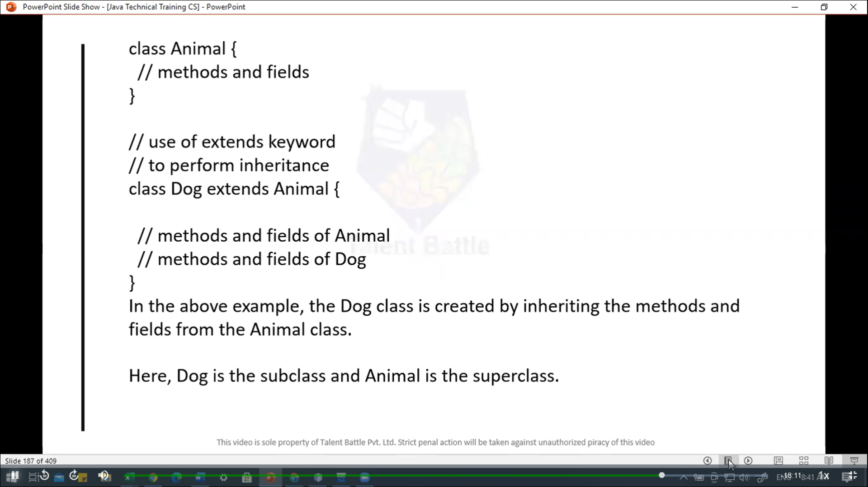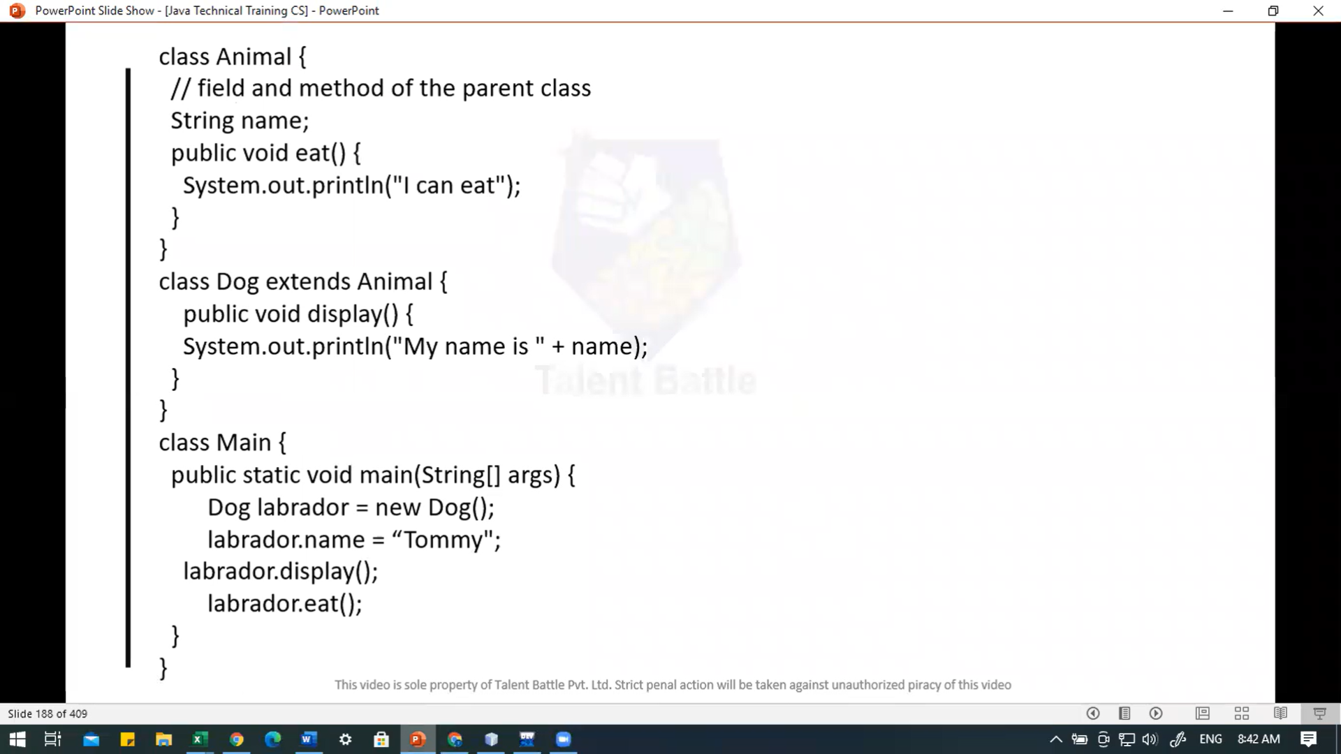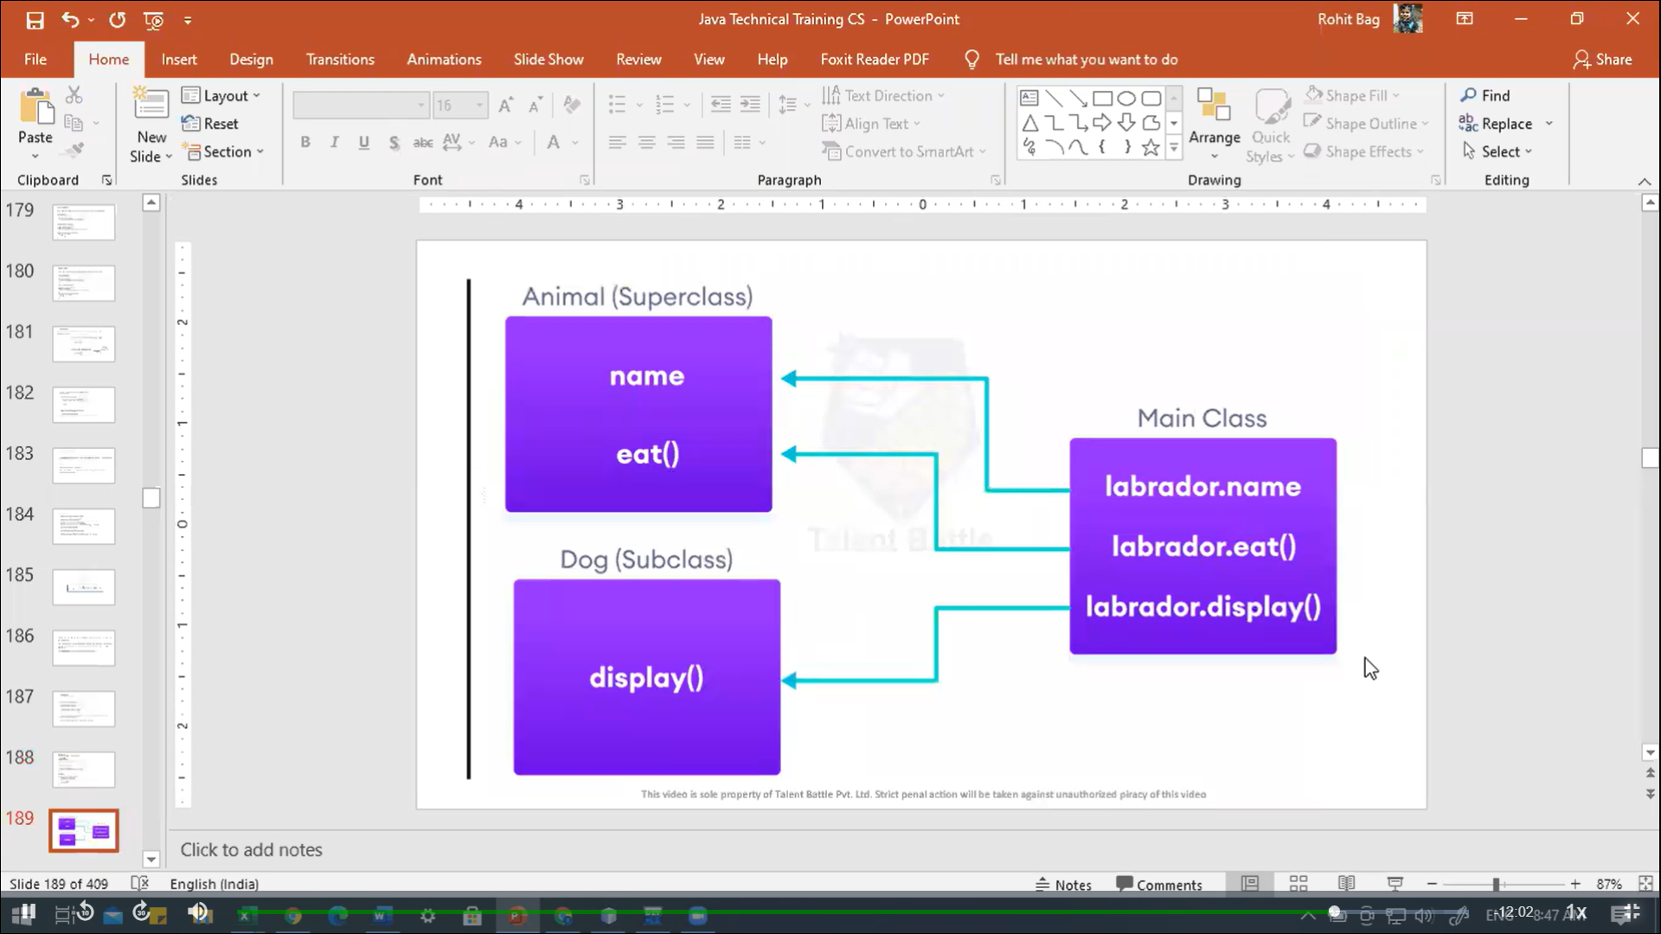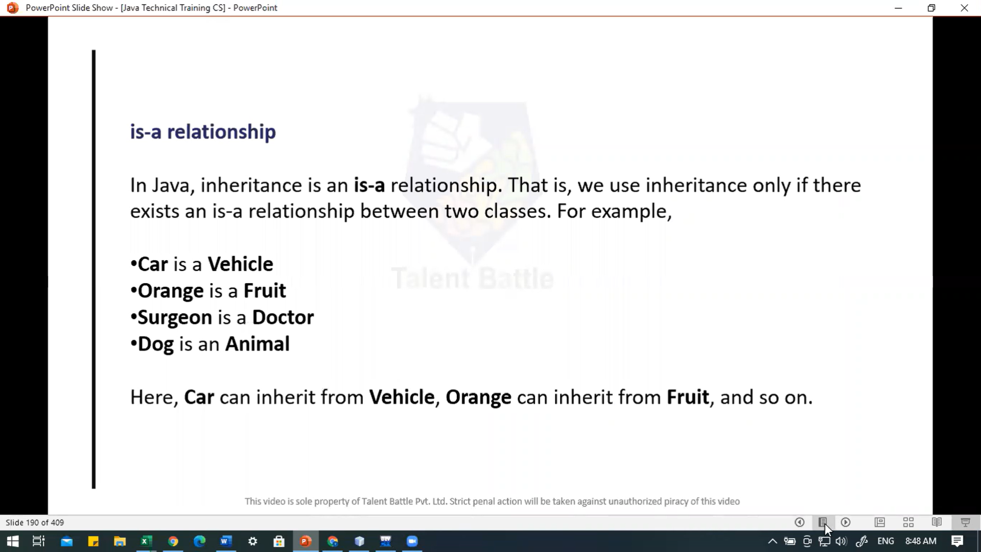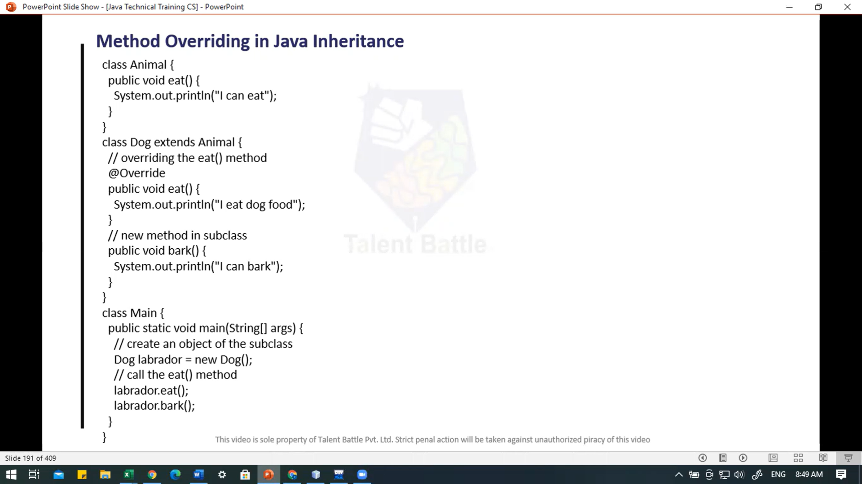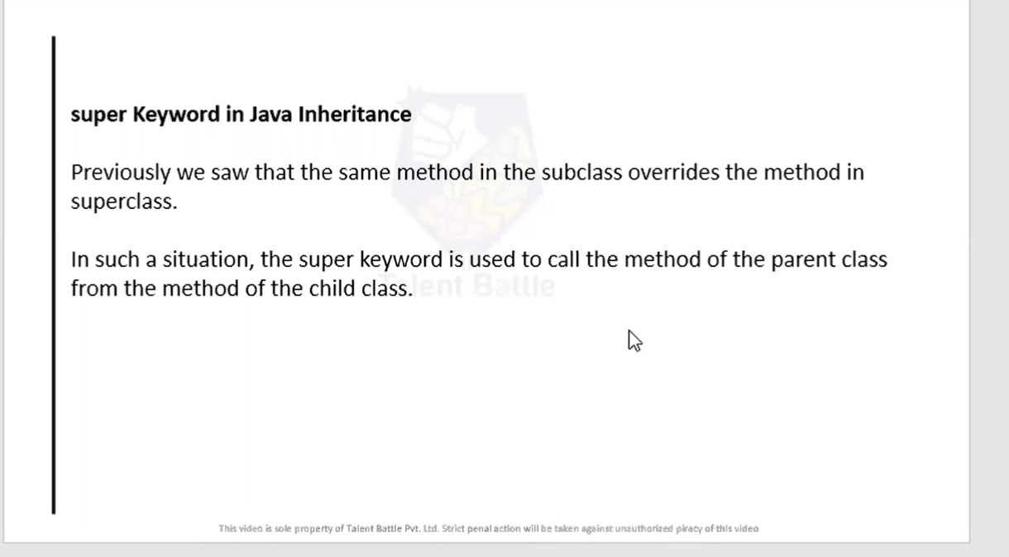

package Day6;

*/\**

*// Note: We cannot declare classes and interfaces private in java*

*// Private Access Modifier*

*class Data{*

*// private variable*

*private String name;*

*// getter method*

*public String getName(){*

*return this.name;*

*}*

*// setter method*

*public  void setName(String name){*

*this.name = name;*

*}*

*}*

*public class Main {*

*public static void main(String[] args) {*

*// create an object of Data*

*Data d = new Data();*

*// access the private variable using the getter and setter*

*d.setName("Programming");*

*System.out.println(d.getName());*

*}*

*}*

*// ============= output ================*

*// PS C:\Users\hp\Desktop\TCS IT\Java> java Day6.Main*

*// Programming*

*\*/*

*//----------------------------------------------------------*

*/\**

*// Public Access Modifier*

*// When methods, variables, classes, and so on are declared public, then we cna access them from anywhere. The public access modifier has no scope restriction.*

*class Animal {*

*// public variable*

*public int legCount;*

*// public method*

*public void display(){*

*System.out.println("I am an animal.");*

*System.out.println("I have " + legCount + " legs.");*

*}*

*}*

*public class Main {*

*public static void main(String[] args) {*

*// accessing the public class*

*Animal animal = new Animal();*

*// accessing the public variable*

*animal.legCount = 4;*

*// accessing the public method*

*animal.display();*

*}*

*}*

*// ==================== output ====================*

*//  PS C:\Users\hp\Desktop\TCS IT\Java>  c:; cd 'c:\Users\hp\Desktop\TCS IT\Java'; & 'C:\Program Files\Java\jdk-21\bin\java.exe' '-XX:+ShowCodeDetailsInExceptionMessages' '-cp' 'C:\Users\hp\AppData\Roaming\Code\User\workspaceStorage\3f5645188fb5b1977966aea27e202e46\redhat.java\jdt_ws\Java_a379e1ef\bin' 'Day6.Main'*

*// I am an animal.*

*// I have 4 legs.*

*// PS C:\Users\hp\Desktop\TCS IT\Java>*

*// =============== different method to get output ===================*

*// PS C:\Users\hp\Desktop\TCS IT\Java> java Day6.Main*

*// I am an animal.*

*// I have 4 legs.*

*// PS C:\Users\hp\Desktop\TCS IT\Java>*

*\*/*

*// ------------------------------------------------------*

*/\**

*// Java this keyword*

*// In java, this keyword is used to refer to the current object inside a method or a constructor.*

*// this  is nothing but the reference to the current  object.*

*class Main{*

*int instVar;*

*Main(int instVar){*

*this.instVar = instVar;*

*System.out.println("this reerence = " + this);*

*}*

*public static void main(String[] args) {*

*// creating an object of the class*

*Main obj = new Main(10);*

*System.out.println("Object reference = " + obj);*

*}*

*}*

*// ============= output ======================*

*// PS C:\Users\hp\Desktop\TCS IT\Java\Day6> java .\Main.java*

*// this reerence = Day6.Main@473b46c3*

*// Object reference = Day6.Main@473b46c3*

*\*/*

*//---------------------------------------------------------*

*/\**

*// First,let's see an example without using this keyword:*

*class Main{*

*int age;*

*Main(int age){*

*age = age;*

*}*

*public static void main(String[] args) {*

*// creating an object of the class*

*Main obj = new Main(10);*

*System.out.println("Object reference = " + obj.age);*

*}*

*}*

*// ================ output ===================*

*//  PS C:\Users\hp\Desktop\TCS IT\Java\Day6> java .\Main.java*

*// Object reference = 0*

*\*/*

*// ------------------------------------------------------------*

*/\**

*// Now, let's rewrite the code using this keyword.*

*// Now, we are getting this expected output. It is because when the constructor is called, this inside the constructor is replaced by the object obj that has called the constructor. Hence the age variable is assigned value 8.*

*class Main{*

*int age;*

*Main(int age){*

*this.age = age;*

*}*

*public static void main(String[] args) {*

*// creating an object of the class*

*Main obj = new Main(8);*

*System.out.println("obj.age = " + obj.age);*

*}*

*}*

*// ================== output*

*//  PS C:\Users\hp\Desktop\TCS IT\Java\Day6> java .\Main.java*

*// obj.age = 8*

*\*/*

*// --------------------------------------------*

*/\**

*// this with Getters and Setters*

*// Here, we have used this keyword:*

*// - to assign  value inside the setter method*

*// - to access value inside the getter method*

*class Main {*

*String name;  // instance*

*// setter method*

*void setName(String name)  // String name is parameter*

*{*

*this.name = name;*

*}*

*// getter method*

*String getName(){*

*return this.name;*

*}*

*public static void main(String[] args) {*

*// creating an object of the class*

*Main obj = new Main();*

*// calling the setter and the getter method*

*obj.setName("Toshiba");*

*System.out.println("obj.name: " + obj.getName());*

*}*

*}*

*// =============== output ======================*

*// PS C:\Users\hp\Desktop\TCS IT\Java\Day6> java .\Main.java*

*// obj.name: Toshiba*

*\*/*

*//--------------------------------------------------------*

*/\**

*// In java, we cannot  change the value of a final variable.*

*// Note: It is recommended to use uppercase to declare final variables in java*

*class Main{*

*public static void main(String[] args){*

*// create a final variable*

*final int  AGE = 32;*

*// try to change the final variable*

*// AGE = 45; //  will gives error*

*// Exception in thread "main" java.lang.Error: Unresolved compilation problem:*

*// The final local variable AGE cannot be assigned. It must be blank and not using a compound assignment*

*System.out.println("Age: " + AGE);*

*}*

*}*

*// =================== output ====================*

*// PS C:\Users\hp\Desktop\TCS IT\Java\Day6> java Main.java*

*// Age: 32*

*\*/*

*// -------------------------------------------------------*

*/\**

*// Java final Method*

*// In java, the final method cannot be overriden by the child class.*

*class FinalDemo{*

*// create a final method*

*public final void display(){*

*System.out.println("This is a final method.");*

*}*

*}*

*class Main extends FinalDemo {*

*// try to override the final method*

*public final void display(){*

*System.out.println("The final method is overriden.");*

*}*

*// Exception in thread "main" java.lang.Error: Unresolved compilation problem:*

*// The final method display() cannot be overridden.*

*public static void main(String[] args) {*

*Main obj = new Main();*

*obj.display();*

*}*

*}*

*//=============== output ========================*

*// PS C:\Users\hp\Desktop\TCS IT\Java\Day6> java Main.java*

*// Main.java:258: error: display() in Main cannot override display() in FinalDemo*

*//   public final void display(){*

*//                     ^*

*//   overridden method is final*

*// 1 error*

*// error: compilation failed*

*\*/*

*// ----------------------------------------------------------------*

*/\**

*// Example: Factorial of a Number Using Recursion*

*class Factorial{*

*static int factorial(int n){*

*if(n != 0) // termination condition*

*return n * factorial(n-1); // recursive call*

*else{*

*return 1; // base case*

*}*

*}*

*public static void main(String[] args){*

*int number = 4, result;*

*result = factorial(number);*

*System.out.println("Factorial of " + number + " = " + result);*

*}*

*}*

*// +++++++++++++ output ++++++++++++++++++++*

*// PS C:\Users\hp\Desktop\TCS IT\Java> javac Day6/Main.java*

*// PS C:\Users\hp\Desktop\TCS IT\Java> java Day6.Factorial*

*// Factorial of 4 = 24*

*\*/*

*//--------------------------------------------------------*

*/\**

*class Main{*

*public static void main(String[] args) {*

*// create a variable of string type*

*String name = "Programming";*

*// checks if name is instance of String*

*boolean result1 = name instanceof String;*

*System.out.println("name is an instance of String: " + result1);*

*// create an object of Main*

*Main obj = new Main();*

*// checks if obj is an instance of Main*

*boolean result2 = obj instanceof Main;*

*System.out.println("obj is an instance of Main: " + result2);*

*}*

*}*

*//  ++++++++++++++++ output ++++++++++++++++++++++*

*// @Dheeraj2002kumar ➜ /workspaces/Foundation-Language/Java (main) $ javac Day6/Main.java*

*// @Dheeraj2002kumar ➜ /workspaces/Foundation-Language/Java (main) $ java Day6.Main*

*// name is an instance of String: true*

*// obj is an instance of Main: true*

*\*/*

*//----------------------------------------------------------*

*/\**

*// Inheritance*

*class Animal{*

*// field and method of the parent class*

*String name;*

*public void eat(){*

*System.out.println("I can eat");*

*}*

*}*

*class Dog extends Animal{*

*public void display(){*

*System.out.println("My name is " + name);*

*}*

*}*

*class Main{*

*public static void main(String[] args){*

*Dog labrador = new Dog();*

*labrador.name = "Tommy";*

*labrador.display();*

*labrador.eat();*

*}*

*}*

*//++++++++++++++ output ++++++++++++++++*

*// @Dheeraj2002kumar ➜ /workspaces/Foundation-Language/Java (main) $ javac Day6/Main.java*

*// @Dheeraj2002kumar ➜ /workspaces/Foundation-Language/Java (main) $ java Day6.Main*

*// My name is Tommy*

*// I can eat*

*\*/*

*//-------------------------------------------------------*

*/\**

*// Method Overriding in Java Inheritance*

*class Animal{*

*public void eat(){*

*System.out.println("I can eat");*

*}*

*}*

*class Dog extends Animal{*

*// overriding the eat() method*

*@Override*

*public void eat(){*

*System.out.println("I eat dog food..");*

*}*

*// new method in subclass*

*public void bark(){*

*System.out.println("I can bark");*

*}*

*}*

*class Main{*

*public static void main(String[] args) {*

*// create an object of the subclass*

*Dog labrador = new Dog();*

*// call the eat() method*

*labrador.eat();*

*labrador.bark();*

*}*

*}*

*// ++++++++++++++ output ++++++++++++++++++*

*//  @Dheeraj2002kumar ➜ /workspaces/Foundation-Language/Java (main) $ javac Day6/M*

*// ain.java*

*// @Dheeraj2002kumar ➜ /workspaces/Foundation-Language/Java (main) $ java  Day6/M*

*// ain.java*

*// error: can't find main(String[]) method in class: Day6.Animal*

*// @Dheeraj2002kumar ➜ /workspaces/Foundation-Language/Java (main) $ java Day6.Main*

*// I eat dog food..*

*// I can bark*

*\*/*

*// =================================================*

*// Super keyword in java inheritance*

**class** Animal{

**public** **void** eat(){

    System.out.println("I can eat");

  }

}

**class** Dog **extends** Animal{

*// overriding the eat() method*

  @**Override**

**public** **void** eat(){

*// call method of superclass*

    super.eat();

    System.out.println("I eat dog food..");

  }

*// new method in subclass*

**public** **void** bark(){

    System.out.println("I can bark....");

  }

}

**public** **class** Main {

**public** **static** **void** main(String[] args) {

    Dog labrador = new Dog();

*// call the eat() method*

    labrador.eat();

    labrador.bark();

  }

}

*// ++++++++++++++++++ output +++++++++++++++++++++*

*// @Dheeraj2002kumar ➜ /workspaces/Foundation-Language/Java (main) $ javac Day6/Main.java*

*// @Dheeraj2002kumar ➜ /workspaces/Foundation-Language/Java (main) $ java Day6.Main*

*// I can eat*

*// I eat dog food..*

*// I can bark....*